Hands On: AWS VPC Essentials
(Part – 2.2)
AWS VPC Private Link – Endpoint Service

You can create your own service powered by AWS PrivateLink, known as an endpoint service. You are the service provider, and the AWS principals that create connections to your service are the service consumers.
Endpoint services require either a Network Load Balancer or a Gateway Load Balancer. The load balancer receives requests from service consumers and routes them to your service.
Considerations
- An endpoint service is available in the Region where you created it. You can access the endpoint service from other Regions using VPC peering.
- An endpoint service supports traffic only over TCP.
- When service consumers send traffic to a service through an interface endpoint, the source IP addresses provided to the application are the private IP addresses of the load balancer nodes, not the IP addresses of the service consumers.
- If your Network Load Balancer has a security group, it must allow inbound traffic from the IP addresses of the clients.
- Choose TCP protocol with port 80 in Network load balancer for communication to Endpoint service.
- Also edit inbound rule of security group of provider resource (Provider private ec2 instance) for http protocol.
- Private DNS: Enable private DNS names for the VPC endpoint to resolve the service names within the VPC.

Architectural Diagram
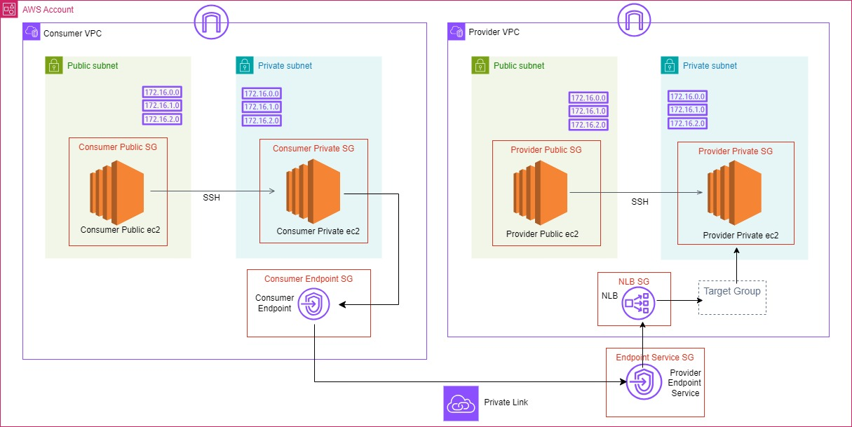
Hands – On
Steps:
- Create the VPC Infra
- Create two VPC’s as per the Architectural diagram.
Consumer VPC: mycloud-consumer-vpc
Provider VPC: mycloud-provider-vpc
- Each VPC contain a private and public subnet with an EC2 instances.
- In Provider VPC, we have installed an Apache webserver in private EC2 instance and host a “Hello world” html webpage through Bootstrap script.
- And consider this as the Service which accessed from the PrivateLink Endpoint service.
- Edit the Inbound rule of the Security group associated with private instance in provider VPC with allow http – port 80 from anywhere ipv4.

- Configure Target Group
- Open the EC2 Dashboard
- In the navigation pane, under "Load Balancing", choose "Target Groups".
- Click on the "Create target group" button.
- Choose a target type: Select Instances
- Target group name: mycloud-provider-tg
- Protocol: Choose the protocol HTTP – port 80
- VPC: Choose the VPC - mycloud-provider-vpc
- Health checks: leave as default
- Register Targets: Select the instances – mycloud-provider-private-ec2.
- Review and create.
- Configure Network Load balancer
- Navigate to Load Balancers.
- Click on the "Create Load Balancer" button.
- Choose "Create" under the "Network Load Balancer" section.
- Name: mycloud-provider-nlb
- Scheme: Choose "Internal".
- IP address type: Choose IPv4.
- Listeners: By default, a listener for TCP on port 80 is created.
- Select the VPC: mycloud-provider-vpc and the Availability Zone as eu-north-1.
- Create a Security group - mycloud-provider-nlb-sg: edit the Inbound rule with http-port 80 from anywhere ipv4.
- Register Targets: select the existing target group - mycloud-provider-tg.
- Review your settings and click "Create" to create the load balancer.
- Configure Provider Endpoint Service
- Open the Amazon VPC console
- In the navigation pane, choose Endpoint services.
- Choose Create endpoint service.
(Or in Network load balancer – Integrations – Endpoint Services.)
- For Load balancer type, choose Network.
- For Available load balancers, select the Network Load Balancer - mycloud-provider-nlb to associate with the endpoint service. Included Availability Zones lists the Availability Zones that are enabled for the selected Network Load Balancers. Your endpoint service will be available in these Availability Zones.
- For Require acceptance for endpoint, select Acceptance required to require that connection requests to your endpoint service are accepted manually. Otherwise, these requests are accepted automatically.
- For Supported IP address types - Select IPv4
- Choose Create.

- Setup Consumer VPC Endpoint
- Open the Amazon VPC console
- In the navigation pane, choose Endpoint
- Give the Name: mycloud-consumer-vpc-endpoint
- Choose service Category: Other endpoint services
- Service settings – for service name copy the VPC endpoint service name from the created provider vpc endpoint service.
- And click on verify service.
- VPC: choose the consumer vpc - mycloud-consumer-vpc
- Under subnet: select the private subnet of consumer vpc - mycloud-consumer-private-subnet
- IP address type: ipv4
- Create a separate security group for Endpoint with below details;
Name: mycloud-consumer-endpoint-sg
Inbound rule: allow http from anywhere ipv4
Outbound rule: allow all traffic from anywhere ipv4
- Select the created security group for this endpoint.
- Click on create endpoint

- Access the Endpoint service from consumer VPC
- ssh into the public instance of the consumer vpc
- connect ssh into the private instance of the consumer vpc
- run the below command to see the service from provider vpc through the Endpoint service created powered by the private link.

Curl <DNS name of the consumer vpc endpoint>

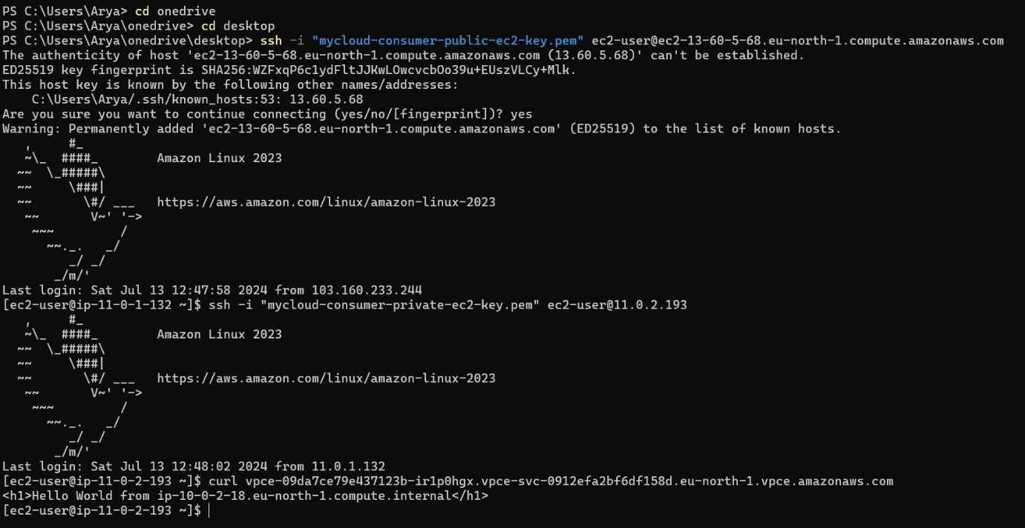
The curl command is a tool used to transfer data from or to a server using various protocols such as HTTP, HTTPS, FTP, and more.
Here’s a simple example:

curl vpce-12345-abcde.vpce.amazonaws.com
In this case:
- vpce-12345-abcde.vpce.amazonaws.com is the DNS name of the VPC endpoint.
- curl sends a GET request to this endpoint.
- The response from the server (HTML, JSON, etc.) will be displayed in the terminal.

--End--

